Design Your Own Book Cover

The Butter Krust Bread Company often passed out book covers to local school children. Using the information that you have learned, design a book cover that describes the history of the Richter Baking Company/ Butter Krust.

Instructions

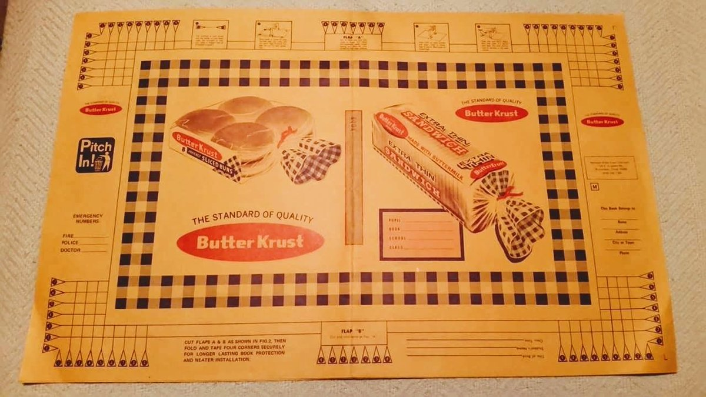

Right Side: Name, Title of the book, and a picture
Center: Please create a timeline of 3 significant events
Left: Write a succinct summary of what the book is about. (5-7 sentence max)

Link to the Canva Template:
https://www.canva.com/design/DAEcJ3VO_Ag/R0A6Lkpada3R8pm2rvfo9A/view?utm_content=DAEcJ3VO_Ag&utm_campaign=designshare&utm_medium=link&utm_source=publishsharelink&mode=preview

*Link to Screen Recording of how to access Canva

Rubric Categories:
Required Sections
Visual Presentation
Historical Knowledge
Spelling and Mechanics

