Instructions: Can you locate and mark significant cities and state that pertain to the Stinson family. You may use information located within the Stinson website. Extra Credit if you correctly write and pinpoint the city and state.

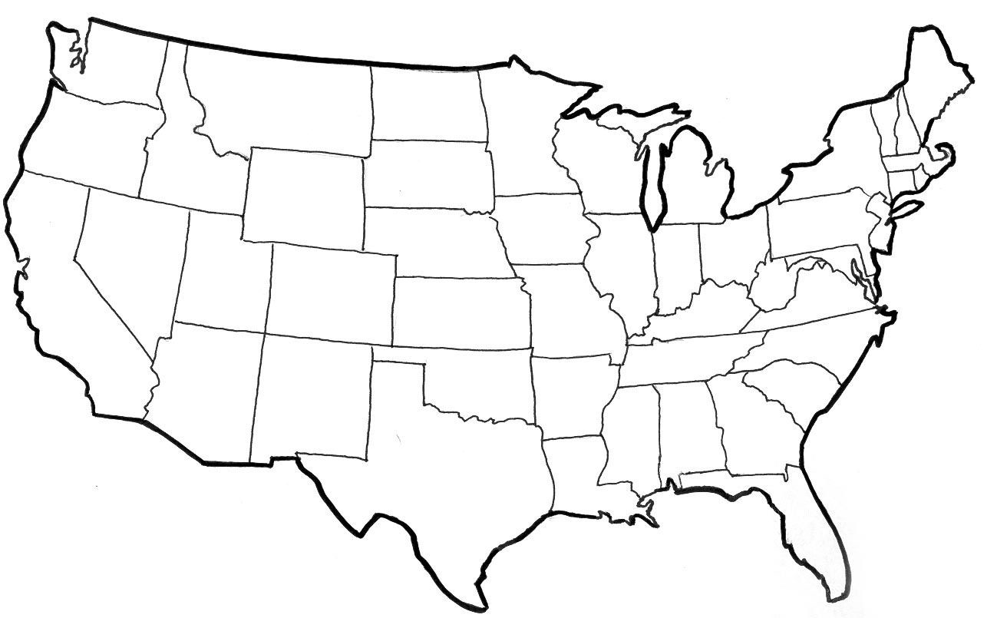

Map: mapsofusa.net

